BATTLE REALM

Objective: Collect and battle with a deck of powerful creatures, magical spells, and formidable equipment in an all-out fight to dominate the realm.
Gameplay: Each player starts with a deck of cards and a set amount of health points. Players take turns drawing cards and using them to summon creatures and cast spells on the battlefield. Each card has a set number of attack and defense points and unique abilities that can be used to gain the upper hand. The aim of the game is to reduce your opponent's health points to zero.
Possible Types of Cards:
1. Creatures - Dragons, demons, warriors, and sorcerers with unique attack and defense abilities
2. Spells - Fireballs, ice storms, healing potions, banishments, and curses
3. Equipment - Swords, shields, armor, and talismans that boost a creature's stats or give it special abilities
4. Locations - Castles, forests, caves, and temples that influence the outcome of battles
There's a potential for thousands of cards with unlimited combinations of attributes and abilities, making the game endlessly replayable. Players can purchase booster packs containing new cards to add to their collection, participating in online tournaments, and expanding their strategies!

basic creatures for Battle Realm card game:
1. Soldier
2. Archer
3. Scout
4. Warrior
5. Knight
6. Cleric
7. Magician
8. White Mage
9. Black Mage
10. Red Mage
11. Paladin
12. Mage Knight
13. Shadow Mage
14. Gunner
15. Hitman
16. Golem
17. Elemental
18. Giant
19. Ogre
20. Cyclops
21. Manticore
22. Hydra
23. Bugbear
24. Behemoth
25. Troll
26. Mermaid
27. Kraken
28. Sea Serpent
29. Shark
30. Siren
31. Fairy
32. Pixie
33. Unicorn
34. Phoenix
35. Griffin
36. Chimera
37. Dragon
38. Wyrm
39. Gargoyle
40. Harpy
41. Minotaur
42. Sphynx
43. Cerberus
44. Hellhound
45. Demon
46. Imp
47. Satyr
48. Healer
49. Thief
50. Rogue
51. Shade
52. Ghost
53. Banshee
54. Specter
55. Shadow
56. Dark Knight
57. Djinni
58. Wraith
59. Revenant
60. Leviathan
61. Wisp
62. Poltergeist
63. Wendigo
64. Ooze
65. Slime
66. Gelatin
67. Carnivorous Plant
68. Dryad
69. Simulacrum
70. Vampire
71. Necromancer
72. Spectral Hound
73. Skeleton
74. Zombie
75. Ghoul
76. Gnome
77. Undead Warrior
78. Undead Archer
79. Mummy
80. Harbinger
81. Gorgon
82. Medusa
83. Basilisk
84. Titan
85. Titan's Minion
86. Titan's Heir
87. Anointed Knight
88. Mystic Botanical
89. Elf
90. Dwarf
91. Ice Golem
92. Stone Golem
93. Fire Golem
94. Dark Sorcerer
95. Fire Elemental
96. Water Elemental
97. Electric Elemental
98. Air Elemental
99. Sand Elemental
100. Fog Elemental
101. Dark Wizard
102. Lightning Catcher
103. Ice Catcher
104. Warlock
105. Magical Beast Tamer
106. Mystic Beast Quiz
107. Winged Steed
108. Behemoth Lord
109. Beastman
110. Ghoul Warrior
111. Lascar
112. Wyvern
113. Harpy Assassin
114. Mimic
115. Hobgoblin
116. Skeletal Soldier
117. Mummy Warrior
118. Zombie King
119. Scorpion
120. Seta
121. Succubus
122. Angel
123.Winged Champion
124. Peacekeeping Cannon
125.Stormlighter
126. Molten Lava Elemental
127. Crystal Serpent
128. Phantom Stag
129. Sky Bison
130. Scorched Salamander
131. Devouring Void
132. giant clam
133. Shifting Sands Djinn
134. Alien Grunt
135. Azure Lion
136. Obsidian Crusader
137. Evasive Shrimp
138. Bloodhaze Spider
139. Ornery Goat
140. Frozen Husk
141. Steel Beetle
142. Fiery Phoenix
143. Night Terror
144. Thunderbird Sentinel
145. Arctic Arcticwolf
146. Storm-Wracked Kraken
147. Veiled Witch
148. Felguard Captain
149. Cursed Pegasus
150. Fading Wraith
151. Flaring Minotaur
152. Owasp-terror
153. ArmoredElephant
154. Kinetic Devourer
155. Brood Parasite
156. Stealthy Panther
157. Entangling Vines
158. Enson Plushie
159. Reaving Drake
160. Phantom Thief
161. Spinecurse Beetle
162. Foldabot
163. Dwarven Shieldmaid
164. Element Guardian of Harmony
165. Starlight Poodle
166. Fork-tail Wyrm
168. Strangler Creeper
169. Battle Ent
170. Singed Serpent
171. Talon Bat
172. Serpent Berserker
173. Wendigo Shifter
174. Mythos Minotaur
175. Corrupted Corpse
176. Moonbeam Elk
177. Bonewrought Dragonspawn
178. Arboreal Gigantopithecus
179. Lunar Moth
180. Harrowing Harpy
181. Grey Wolf
182. Behemoth Knight
183. Possessing Daemon
184. Fel Drake Descendant
185. Floating Candle Wisp
186. Quicksilver Wyvern
187. Burning Skull Spider
188. Ao Oni
189. Onyx Jaguar
190. Crystal Guardian
191. Soul Scourge
192. Necrotic Skeletal Warrior
193. Abyssal Tiger
194. Tactilis Sorcerer
195. Burning Gargoyle
196. Stylish Sylph
197. Flamemoore Mephit
198. Blaze Berserker
199. Pale Viper
200. Netherworld Grizzly
201. Slime Crab
202. Thundercrusher Ram
203. Cyclops Goliath
204. Behemoth Vulture
205. Glowgator
206. Revenant Necromancer
207. Freezing Rattlesnake
208. Demonic Scorpion
209. Blackbone Mammoth
210. Winged Bear
211. Smoldering Bat
212. Shadowhawk
213. Great Fox Spirit
214. Direnettle Weed
215. Human Mind Slaver
216. Ascended Auto-Mech
217. Glacial Salamander
218. Rusting Golem
219. Frost Ent
220. Blaze Liger
221. Unbound Elemental
222. Electrifying Scout
223. Darkforce Incarnate
224. Soul-reapingJuggernaut
225. Chimera Lord

advanced creatures for Battle Realm:
1. Archangel
2. Black Dragon
3. Gold Dragon
4. Silver Dragon
5. Abyssal Demon
6. Celestial Demon
7. Angelic Bard
8. Chimeric Beast
9. Phoenix Queen
10. Desolate Dragon
11. Gorgon Queen
12. Kraken Overlord
13. Sandworm
14. Mindflayer
15. Giant Mummy
16. Living Corpse
17. Thunderbird
18. Harpy Queen
19. Mermaid Queen
20. Griffon Rider
21. Frost Giant
22. Titan’s Titan
23. Demon Paladin
24. Marshmallow Monster
25. Wraith King
26. Hydra Overlord
27. Chiron the Centaur
28. Sphinx Queen
29. Infernal Succubus
30. Valkyrie
31. Fluxquid
32. Purple Gayansura Doeltuk
33. Spooky Skeleton
34. Orb of Seers
35. Sylvan Argonaut
36. Gladiator Angel
37. Kraken Champion
38. Dragonslayer
39. Demi-Lich
40. Exarch Quester
41. Mechanical Dragon
42. Tusker
43. Garuda Rider
44. Leviathan Queen
45. Tyrannical T-Rex
46. Griffon Lord
47. Treefolk Giant
48. Lamia Empress
49. Pygmy Orc
50. Gargoyle Lord
51. Dragoon
52. Mu-Aryansura Neotuac (the horned one)
53. Sea Dragon
54. Ice Behemoth
55. Dark Mermaid
56. Thunder Rhino
57. Great Leviathan Enforcer
58. Gargoyle Warlock
59. Succubus Empress
60. Sky Whales
61. Samuarian
62. Raptor Riders
63. Ape Overlord
64. Fae Prince
65. Grenadier of the Dreamweavers
66. Doppelganger
67. Elementofragment
68. Sun Titan
69. Storm Giant
70. Frost Succubus
71. Demon Mage
72. Winged Gorgon Queen
73. Hydra Champion
74. Copper Snake
75. Athena (The Greek Goddess)
76. Succubus Princess
77. Dark Elf Warlock
78. Crystal Golem
79. Holy Mummy
80. Mermaid Sorceress
81. Chimera Overlord
82. Necrotic Corps
83. Dragon Emperor
84. Dragon Summoner
85. Infernal Angel
86. Frost Golem
87. Divine Unicorn
88. Malicious Troll
89. Leviathan Champion
90. Frost Witch
91. Egyptian God
92. Spirit Wolf
93. Gladiators Battalion
94. Sea Serpent Lord
95. Inferno Behemoth
96. Undead Valkyrie
97. Ogre Warlord
98. Mountain Giantess
99. Lamp Adze
100. Succubus Empress II.

God tier creatures for Battle Realm:
1. Chronomancer
2. Sun Elemental
3. Cthulhu
4. Blaze Phoenix
5. Nidhogg
6. Maltheal - The Timeshifter
7. Dragon Deity
8. Tatiana - Queen of Dragons
9. Null Entity
10. Phoenix Emperor
11. Norn’s Priestess
12. Serendipity Angel
13. Ancient Mara
14. Onyx Sphinx
15. Infernogorgon
16. Infernum Beast
17. Cerberus Andante
18. Elven Champion
19. Lornezo Ogaara - The Ruthless Scourge
20. Scarab Ichor (also known as Scarabix)
21. Hellion Squierarch
22. Dhera I’ fharuos
23. Crouch Corche
24. Creature Rosheacalor
25. Capito Abondiendang
26. Australopithecized Slug Lion
27. Lindmakeriva
28. Galmraheratus
29. Srachnursinear
30. Vifisport
31. Bunk Taillzin
32. Rockamegvorack
33. Galormidios Stoken
34. Basnokscoracle
35. Kragh Mestr
36. Gertoeisiean Erahmark
37. Mechagorazareal
38. Lucifeanama
39. Beatalistria Tekra
40. Obsidianravzarion
41. Kaleidisnappgarischon
42. Gerbarithbroge
43. Varniomantax
44. Frauggeroncen
45. Brutalidio
46. Temptrewyfernajir
47. Mortrendmeyorhurde
48. Infernumphloriousae
49. Aingholauphlesgrauphol
50. Jenitzscheragon

basic spells for Battle Realm:
1. Fireball
2. Ice Shard
3. Healing Blessing
4. Thunder Bolt
5. Chain Lightning
6. Teleportation
7. Mind Control
8. Protection Ward
9. Energy Drain
10. Elemental Ray
11. Levitation
12. Invisibility
13. Light Beam
14. Magic Missile
15. Animal Summon
16. Fairy Dust
17. Poison Dart
18. Slow Time
19. Explosion
20. Acid Burst
21. Flame Guard
22. Freeze
23. Tracelessness
24. Mind Blast
25. Hypnosis
26. Cold Snap
27. Sleep
28. Shockwave
29. Continuous Magic Missile
30. Fear
31. Binding
32. Dark Energy
33. Phantom
34. Blinding Light
35. Dragonfire
36. Elemental Shield
37. Divine Smite
38. Haste
39. Paralysis
40. Stone Curse
41. Piercing Light
42. Power Word Kill
43. Rebuke
44. Regeneration
45. Searing Light
46. Shock Sphere
47. Sound Burst
48. Wall of Fire
49. Water Walking
50. Conjure Magical Shield
51. Bless
52. Disease
53. Enlarge
54. Confuse
55. Gravity Field
56. Flight
57. Force Bolt
58. Giant’s Strength
59. Heal Undead
60. Holy Aura
61. Ice Spike
62. Passwall
63. Poison Cloud
64. Sleep Cloud
65. Steelheart
66. Stone Form
67. Thunder Clap
68. Chain Heal
69. Control Fire
70. Deflect Magic
71. Divine Intervention
72. Fiery Blast
73. Ice Armor
74. Lightning Strike
75. Magic Shield

advanced spells for Battle Realm:
1. Meteor Strike
2. Dimension Door
3. Consume Magic
4. Shield of Light
5. Voidblast
6. Arcane Explosion
7. Guardian of the Forest
8. Whisper of Death
9. Graviton Surge
10. Havoc Bolt
11. Shadowform
12. Burning Ground
13. Reanimation
14. Icy Winds
15. Ragnarok
16. Mind Bomb
17. Time Stop
18. Tear Drop
19. Phantom Attack
20. Absolute Zero
21. Elemental Nova
22. Holy Light
23. Elemental Lash
24. Phoenix Rise
25. Blood Curse
26. Spirit Purge
27. Chain Curse
28. Ice Age
29. Ancient Defense
30. Plague
31. Blackout
32. Chains of Enslavement
33. Unholy Sacrifice
34. Acid Rain
35. Dark Reflection
36. Void Shield
37. Crystal Rain
38. Implosion
39. Divine Wind
40. Entangle
41. Eternal Flames
42. Soul Steal
43. Slow Poison
44. Freyablast
45. Einherjar's Gaze
46. Gravitational Collapse
47. Faith in Flames
48. Tombstone
49. Fury of the Cyclone
50. Clone

God tier spells for Battle Realm:
1. Diablo Curse
2. Divine Intervention
3. Eldritch Sphere
4. Godsend
5. Apocalypse
6. Doom Blade
7. Pandora's Box
8. Black Sun
9. Heavenly Light
10. Blood Sacrifice
11. Void Rift
12. Cosmic Ray
13. Ghost Wall
14. Rubicon Gate
15. Teleport Z
16. Celestial Arrow
17. Tempest
18. Enslave Demon
19. Soul Visit
20. Deadly Plague
21. Baleful Jet
22. Oracle Teleportation
23. Divine Thunder
24. Vampiric Torrent
25. Covenant of Blood
26. Holy Grail
27. Apocalypse Blade
28. Everwinter
29. Chaos Reign
30. Primal Force
31. Mark of the Spiral
32. Sigil of Summoning
33. Exalted Miracle
34. Cursed Oppression
35. Sonorous Combusstion
36. Blade Fury
37. Divine Right
38. Golden Hail
39. Curse of Infamy
40. Immolate
41. Binding Barrier
42. Dead Eye Strike
43. Eclipse of Obliteration
44. Vitrify
45. Cacophonic Heaven
46. Spacial Shifter

basic equipment cards for Battle Realm:
1. Short Sword
2. Wooden Shield
3. Leather Armor
4. Healing Herbs
5. Bow and Arrow
6. Rejuvenating Elixir
7. Longsword
8. Battle Axe
9. Steel Shield
10. Plate Armor
11. Magic Staff
12. Amulet of Strength
13. Throwing Knives
14. Chainmail
15. Wand of Fire
16. Ruby Ring
17. Iron Mace
18. Divine Chalice
19. Pike
20. The Feathery Cap
21. Spellbook
22. Holy Symbol
23. Elven Bow
24. Drucheon of Vitality
25. Iron Sword
26. Adamant Shield
27. Ghostblade
28. Sapphire Ring
29. Bow of Betrayal
30. Bracing Shield
31. Shadowed Dagger
32. Soul Repulse
33. Thunder Hammer
34. Light Bracers
35. Summoner's Gem
36. Orb of Knowledge
37. Frost Blade
38. Quick Salve
39. Collapsible Grappling Hook
40. Vial of Poison
41. Thunder Armbraces
42. Smoke Bombs
43. Ruby Necklace
44. Distance Gauntlets
45. Golden Armor

advanced equipment cards for Battle Realm:
1. Glorious Intervenor
2. Sorcerer's Wands
3. Dragonheart Shield
4. Wyrmstrike Mace
5. Cyclone Bow
6. Bane Axe
7. Gloves of Haste
8. Spectral Shroud
9. Staff of the Sea
10. Stormcaller's Shield
11. Bone Spear
12. Celestial Mail
13. Gravestone Sword
14. Rulebreaker
15. Eldritch Pendant
16. Circlet of Curses
17. Silver Seraphim Mace
18. Rune Crown
19. Eternal Disemboweler
20. Triquetra Bracelet
21. Golden Cuirass
22. The Nord Sword
23. Jade Skull Guardian
24. Unicorn’s Wisdom
25. Halamina Shortbow
26. Axe of Annihilation
27. Nirvana Longsword
28. Magic Flute
29. Digital Cannon
30. Magnificent Demon's Blade

God tier equipment cards for Battle Realm:
1. Eye of Ragnarok
2. Blade of Oblivion
3. Aegis of the Gods
4. The Thanos Glove
5. Darkness Master
6. The Celestial Sword
7. Shadow Hunter's Recurve Bow
8. Omniscient's Staff
9. The Genie's Lamp
10. Divine Headdress
11. Holy Hand Grenade
12. The Zephyr Horn
13. Lamp of the Genie King
14. Seraphic Wings
15. Magmacore Greatsword

locations for Battle Realm that have different attributes and bonuses for various classes of hero cards:
1. Frozen Citadel - Offers bonuses to Frost and Ice cards.
2. Necropolis - Offers bonuses to Necromancer and Undead cards.
3. Haunted Woods - Offers bonuses to Phantom and Shadow cards.
4. Steampunk Metropolis - Offers bonuses to Mechanic and Golem cards.
5. Lava Gorge - Offers bonuses to Fire and Pyromancer cards.
6. Elven Glade - Offers bonuses to Elf and Magical creature cards.
7. Thaumaturgic Towers - Offers bonuses to Wizard and Blue Magic cards.
8. Abyssal Pit - Offers bonuses to Demonic and Dark Magic cards.
9. Sacred Vault - Offers bonuses to Holy and Angelic cards.
10. Sky Castle - Offers bonuses to Sky Dreadnought and Gryphon cards.
These locations in Battle Realm should offer unique and different characteristics, granting bonuses that fulfil certain conditions while progressing across every gameplay. For instance, a player using their Frost cards in the Frozen Citadel might receive a stat boost and win bonuses while any Pyromancy user attempting to advance on the Lava Gorge card game board may receive frequent map hurdles.

In Battle Realm, each location card should be drawn into a player's deck similar to regular cards such as creatures, spells, and equipment. However, location cards can only be played at the start of a match, not during gameplay.
Before the game starts, both players must shuffle their decks, then flip over a location card at random and place it down on the table as their current battleground. The location card's condition to be played is whether or not it belongs within their composition.
For instance, if a location offers bonuses to the Fire and Pyromancer card, a player needs to have at least one card in their hand with the "Fire" and "Pyromancer" tags to engage with their opponent at that location. Without any relevant cards, the player must endure the game without location bonuses during gameplay.
Overall, the conditions of the location cards' conditions to play should create a platform for adapting and keeping ownerships up to date to win potent in-game outcomes.

Name: Frozen Citadel
Type: Location
Description: The Frozen Citadel is a cold and unforgiving fortress deep in the frozen wastelands. Any creature that can adapt to the extreme temperatures can unleash its full potential on this battleground. Creatures with the Frost and Ice tags deal extra damage here, and spells of the same type unleash their full power.
Activation Condition: Requires at least one card in your deck with the "Frost" and "Ice" tags to play during the game.
Effect: Creatures with the Frost and Ice tags deal +2 extra damage points when attacking, and spells of the same type deal 2 extra points.
Card Art: The card art can depict the barren and icy summoner battlefield beneath the withering and abandoned battlements of a frozen fortress with several twitching, half-frozen creatures deployed and others emerging from frosty shadows and corners, eagerly engaging in combat against each other with their lethal ice moves around them.
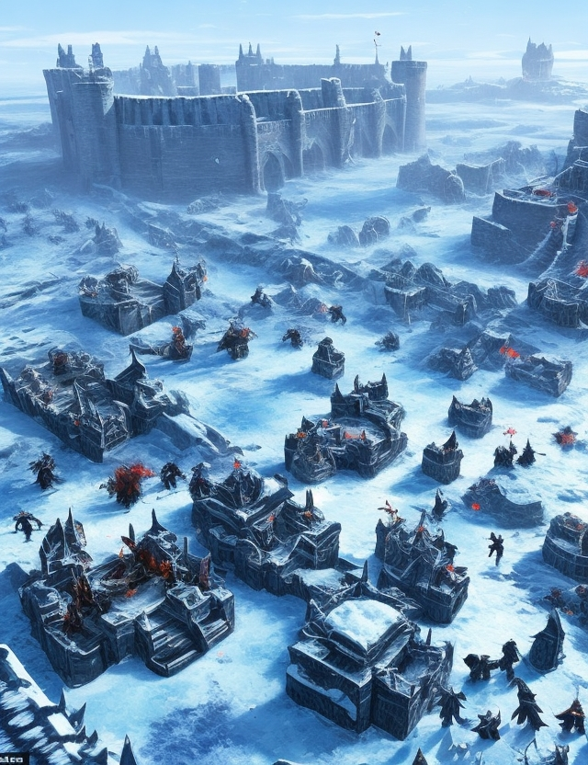

Name: Necropolis
Type: Location
Description: Necropolis is a land of the dead, where the dead learn from cadavers. Creatures that can harness this obscure view can become extremely powerful within its realm. Cards with the "Necromancer" and "Undead" tags receive a boost while on this battleground: they draw extra cards from their deck and get additional resurrection cards on a successful kill.
Activation Condition: Requires at least one card in your deck with the "Necromancer" and "Undead" tags to play it.
Effect: Cards with the "Necromancer" and "Undead" tags receive the ability on a successful kill against enemy cards to resurrect themselves onto the same or adjacent position. Alternatively, upon a failed resurrection, these damaging cards receive extra cards from their deck.
Card Art: The card art can show a large grave or pit in a shadowy battle space filled with disturbed non-chastened cadavers. A Necromancer figure could stand out from behind a considerable vantage point shrouded initiating a heinous spell with various ferocious looking monsters deploying around him.
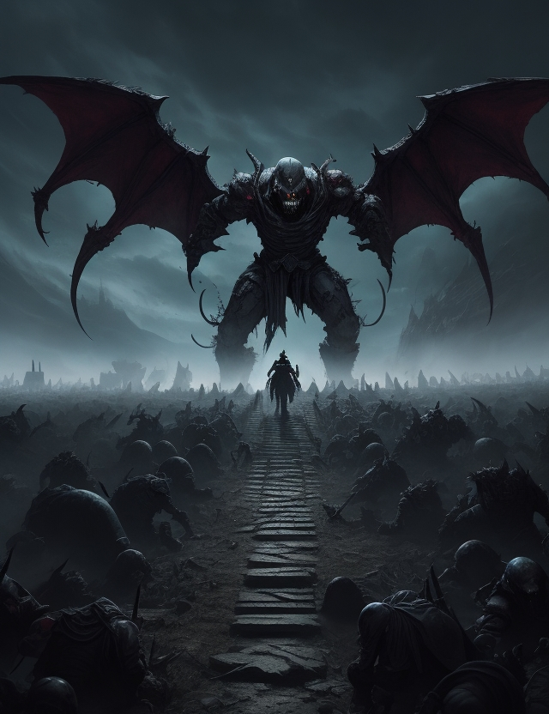

Name: Haunted Woods
Type: Location
Description: The Haunted Woods is a place shrouded in darkness and inhabited by the worst things your nightmares are hiding. Creatures that thrive in dark environments gain an advantage in this battlefield. Cards with the "Shadow" and "Nightmare" tags can blend with the shadows of the woods and deal additional damage to your enemies.
Activation Condition: Requires at least one card in your deck with the "Shadow" and "Nightmare" tags to activate it.
Effect: Cards with the "Shadow" and "Nightmare" tags carry extra stealth abilities for other recruiting against powers on this terrain. Also, your shadow cards will dissolves to evacuate a dangerous monster or strike out from it. They gain +2 attack points for active attacking on this terrain.
Card Art: The card art can picture a twisted and crooked pathway shadowed through the dark on the frills of the foggy woods. In the background, shadow cards some worth frightening-looking spawns such as grotesque spiders or bats joined the nightmare tags stay anxious to work together.
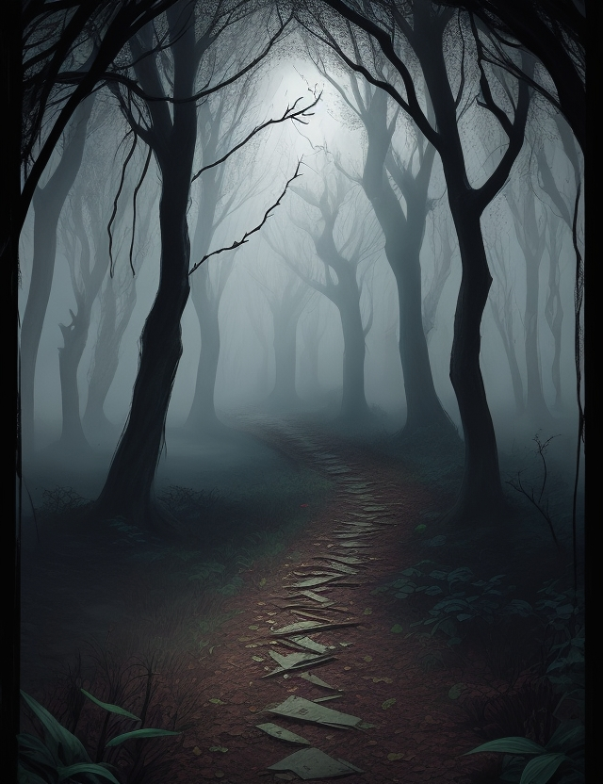

Name: Steampunk Metropolis
Type: Location
Description: Steampunk Metropolis is a city where both art and science merge to bring forth inventions that push the boundaries of what's possible. The creatures that can leverage technology outmatch their opponents on this battleground. Creatures possessing the "Clockwork" and "Gadget" tags gain additional attack potential and automated healing abilities in this environment.
Activation Condition: Requires at least one card in your deck with "Clockwork" and "Gadget" tags to become active during the game.
Effect: Creatures with the "Clockwork" and "Gadget" tags possess less vulnerability on the terrain due to their automated healing ability, granting +1 defense point while they bolster themselves. Also, their clockwork mechanism empowers them with an alternative action: any attacking creature receives 2 additional points to attack on enemy organisms distinctly for additional players into the challenge dice throws.
Card Art: The card art may display the vivid go-live amid the two types of miracles permitting cards to strengthen beside splendid steam generators and extended metallic monster tunnels operated by city configurations. In the beckoning, multi hands contraption discerns impenetrable organism shaped within enthralling animations like lightning flashing out when initiated.
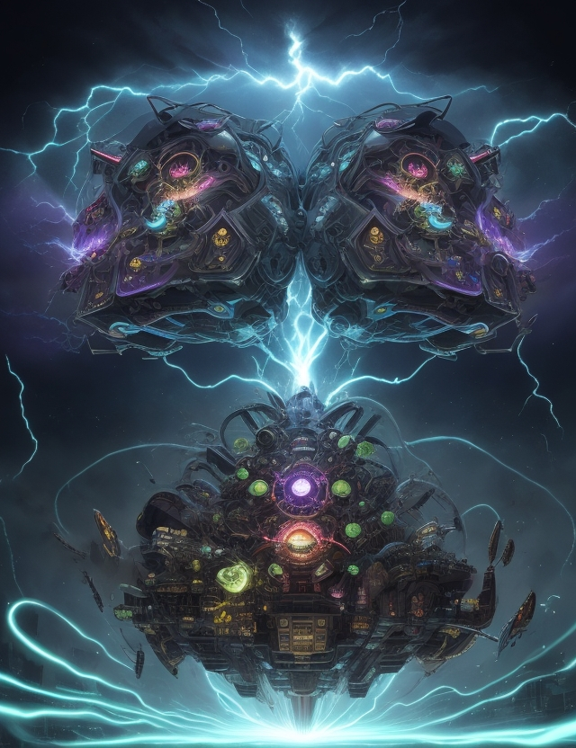

Name: Lava Gorge
Type: Location
Description: Lava Gorge is a treacherous land of erupting volcanoes, spewing lava streams, and rocky ranges that make it challenging for creatures to survive. Creatures that can withstand its heat and terrain hold the upper hand. Cards with the "Fire" and "Rock" tags can flourish in this environment, dealing additional damage to their opponents while withstanding otherwise mystic flames and lava.
Activation Condition: Requires at least one card in your deck with "Fire" and "Rock" tags to activate it.
Effect: Cards with the "Fire" and "Rock" tags carry attributes in lava that protect them, boasting extra defense points. Also, they gain 2 attack points once successful at defending on Lava Gorge, indicating the extra damage they deal to the opponent.
Card Art: The card art showcases Geysers more imposing than water on a mammoth pyroclastic wasteland below aerial glare, simulating broken islets at the apex of dangerous essence releasing into the Lava streams in a vibrant picture. Creatures soaring, swift, or painful in the viscous, boiling terrain underline survival within peril.
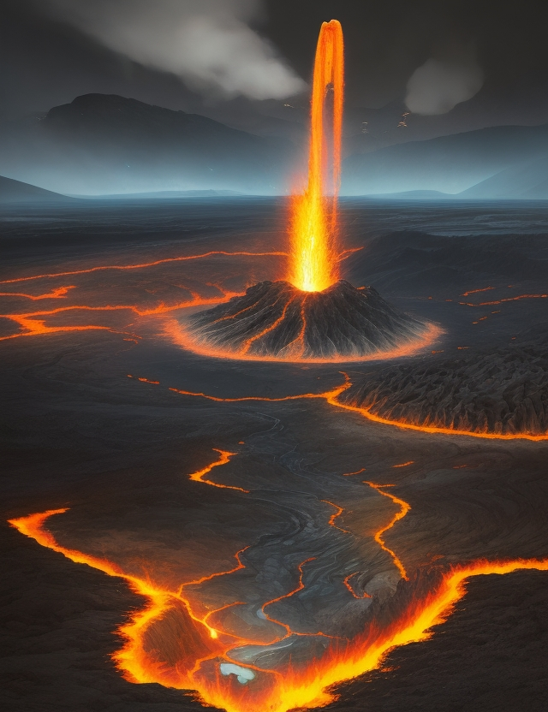

Name: Elven Glade
Type: Location
Description: Elven Glade is a mystical forest where nature and magic come together in harmony. Creatures in touch with the surroundings gain an advantage in this peaceful battleground. Cards with the "Nature" and "Magic" tags gain additional protections and benefits from the powers of this enchanted land.
Activation Condition: Elven Glade activates automatically when at least one card with the "Nature" and "Magic" tags is played on the battleground.
Effect: Cards with the "Nature" and "Magic" tags take advantage of the magical environment and add +1 defense point to their already strong natural defenses. Also, when opposing creatures attack creatures with these tags, they might find it relatively simple- hence the attacking cost rises for opposition from 2 to 3 and effectively loses you a treasure card from your hand from one attack.
Card Art: The card art can portray an exquisitely crafted shaded forest area enveloped in vivid beams of sunshine. With the rays unveiling sneak peeks of light mystical fortifications strewn randomly. A magical elf magus summons the powers of the forest, with various ethereal animals roaming town in the distance.
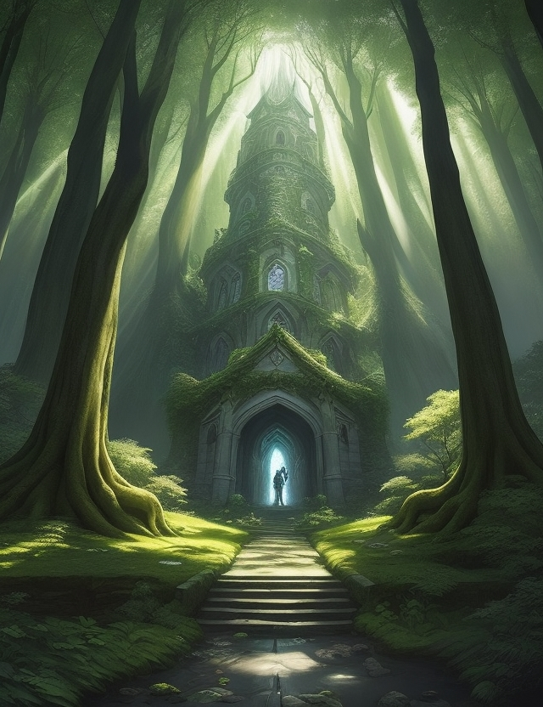

Name: Thaumaturgic Towers
Type: Location
Description: Thaumaturgic Towers are a collection of magical spires erected by ancient wizards. Creatures that have mastered magic and are connected to elementals will find the environment soothing. Cards with the "Ethereal" and "Elemental" tags demonstrate added powers that come to their tending while operating on these grounds by means of their matter sympathetic on this arcane front's attraction.
Activation Condition: Requires at least one card in your deck that comprises the "Ethereal" and "Elemental" tags to produce the semi-magical atmosphere necessary to activate the Thaumaturgic Towers.
Effect: Cards with the "Ethereal" and "Elemental" tags carry an increased aura immediately responding to the situation with +1 attack force or, if opposing attackers choose to challenge, then +1 defense power. They instinctively sense and summon the magical fire of thy towers' presence in need of holding forth their determined war efforts.
Card Art: The card art represents the towering inferno of Thaumaturgic potency, expanding outward into the ether; gas globules shimmering like gala events in the firmament against winged or strange magical mix tags that concoct the spells randomly to let the elemental magus armies flood below visually.
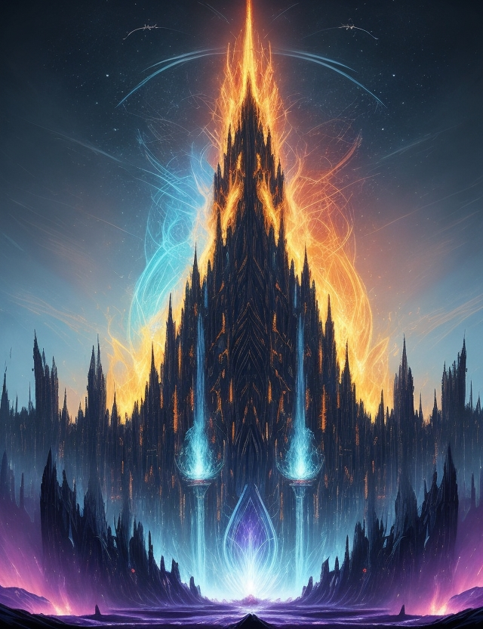

Name: Abyssal Pit
Type: Location
Description: Abyssal Pit is a dark underground den where creatures in touch with darkness and corruption reign supreme. The unwary might enter the battleground, but those who claim the dark powers stand a better chance. Cards with the "Darkness" and "Corruption" tags infuse unnatural control from omnipresent darker intents.
Activation Condition: It autoactivates the opening round-combat and restrains other signs from functioning once it activates.
Effect: Whenever this card executes productive stratagem on Challenger cards that aren't corrupted by the "Darkness" and "Corruption," a sample slight-impossible, in the enemy card - it reveals the bearer. The entry of "Shadow Spawns" creatures allows creatures with the "Darkness" and "Corruption" tags to multiply and infiltrate the battlefield.
Card Art: The art chooses the ample bedrock triangle, spirals underground with eerie light glances resting almost like lair tunnels of dominant shadow-monster in the not-too-distant lines lurking. Magical sigil writings and glyphs degrade into the suffocate climate aloft the cards running toward fight goals with a tingle of uncertainty; creepy but inviting the strategy forms a black aura that turns grow eventually engulfing the middle surrounding.
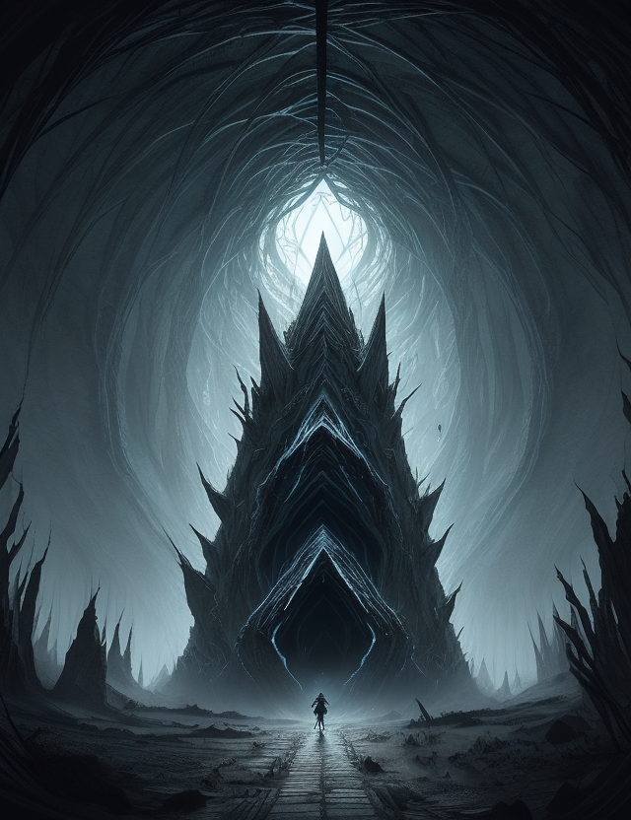

Name: Sacred Vault
Type: Location
Description: Sacred Vault is a holy place, presided over by divine forces that protect and bless war strategists. Cards with the "Light" and "Divine" tags benefit from the radiance illuminating sacred areas dedicated to the gods; their resolutions birth unrecognizable logic on grounds where holy and forgiveness rule the roost.
Activation Condition: The Sacred Vault must come into play when at a higher level than any former activatable location cards within the pretense utility time.
Effect: Cards with the "Light" and "Divine" tags gain a +1 bonus on their maximum occurrence points and no mana costs for activation of associated-special power/arcane ability transforming on blessed terrain with peaceful auras of Lords flowing with feather-graced forms of arcane beauty.
Card Art: The card art is a vision of a godly citadel miraculously untouched and forever immaculate, fortified into yielding an apt guardian reinforced by spiritual media. Spiers loom high above, an astro-shaped column stair deck adorned with multicolored mythological creatures extended weather around. Sky showers are pouring water through each crescent of cloudy rinks hemming at fluted gates welcoming elite creatures sainted by a communal race bonding faith-driven allies amidst their searching strategic calm on the impenetrable terrain.
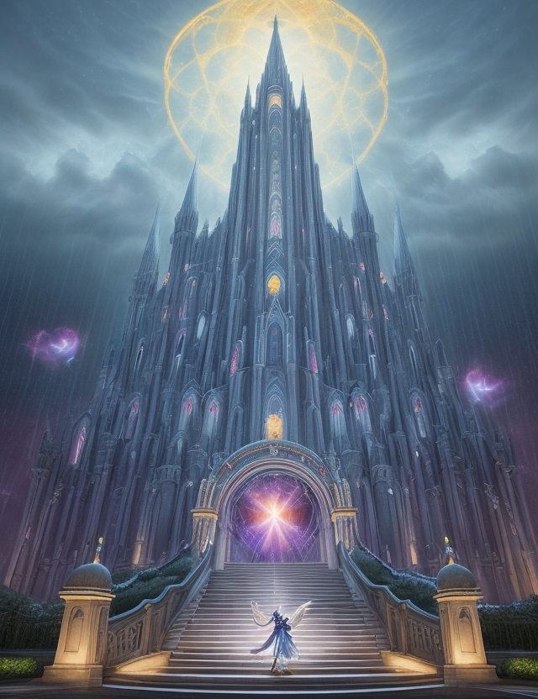

Name: Sky Castle
Type: Location
Description: Sky Castle is a majestic fortress floating high above the clouds that harbors creatures that all possess air-based attributes and abilities. Cards with the "Air" and "Flight" tags are elevated bound hovercraft on slabs of reverie within this environment situated miles high. Battling here requires sturdy wings and a strong grip of the sky-dynamics.
Activation Condition: It activates as soon as one of the Creature cards with "Air" and "Flight" tags resides within the user's deck.
Effect: Cards with the "Air" and "Flight" tags benefit from the rarefied air, giving them an added advantage in their battle efforts, permitting bonus capabilities that further manifest as visions in actual unique warfare, providing a +2 bonus on attack power over lower opponents nonconfirmational supremacy-driven and reducing resistance stats of cards without player modifying their zones respectfully, even with effect-canceling abilities opening attacks befitting swift, airy horizontal or plunging vertical assaults strikes reveal new compositions of tactic exploitation that go quickly behind opponent barrier systems; an unparalleled win-line.
Card Art: The card art is a lush depiction of a wild wonder, built of ethereal, cloudy dreams that shadows across heights of uncertain distance; hovering and gliding allies spilling oversea land below where weightlessness fumbles on a sensation ruled explosive field of action, elegant with concealed tactical finesse flapping invisible as debris grounded zoom forward beneath.


